Ideation Phase
Brainstorm & Idea Prioritization
Date | 10 September 2026
Student Name | Yuvasri Malla
Project Name | Automated Licensed Software Installation Request Management
Maximum Marks | 4 Marks

Brainstorm & Idea Prioritization
The project brainstorm focuses on creating a centralized ServiceNow-based licensed software request management system for employees. The solution handles software requests through the Service Catalog, captures structured request information, supports dynamic form behavior, automates manager approvals, creates fulfillment tasks for the software/IT team, provides notifications and request status tracking, and supports reporting for software requests and license utilization.
Idea | Group | Priority
Service Catalog | User Request Management | High
Licensed Software Request Catalog Item | User Request Management | High
Custom Licensed Software Database Table | Data Management | High
Software Installation Task Management | Task Management | High
Catalog Variables | Structured Data Capture | High
Catalog UI Policies | User Experience | High
Approval Automation | Workflow Automation | High
Automated Software Installation Task Creation | Workflow Automation | High
Assignment to Software Fulfillment Team | Task Management | High
Email Notifications | Communication | Medium
Request Status Tracking | Monitoring | High
Reports and Dashboards | Analytics | Medium

Prioritized Brainstorm Representation
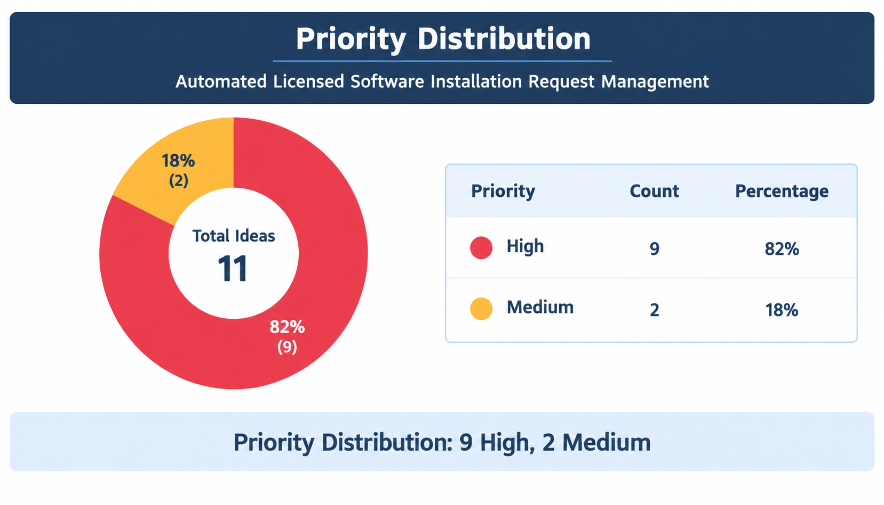
Priority distribution: 10 High, 2 Medium
Ideation Outcome
The prioritized ideas establish the core scope of the project. High-priority items form the minimum functional solution: a Service Catalog request, structured data capture, approval automation, automated fulfillment task creation, team assignment, and request tracking. Medium-priority items enhance communication and analytics through notifications, reports, and dashboards.

